Flat week 2
Task 1:
class Solution {
public int[] buildArray(int[] nums) {

int[] ans = new int[nums.length];

for (int i = 0; i < nums.length; i++) {
ans[i] = nums[nums[i]];
}

return ans;
}
}
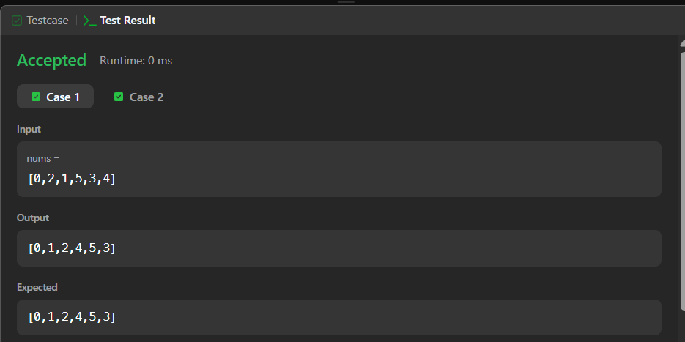
task 2:
class Solution {
public int[] shuffle(int[] nums, int n) {

int[] ans = new int[nums.length];

int index = 0;

for (int i = 0; i < n; i++) {
ans[index++] = nums[i];
ans[index++] = nums[i + n];
}

return ans;
}
}
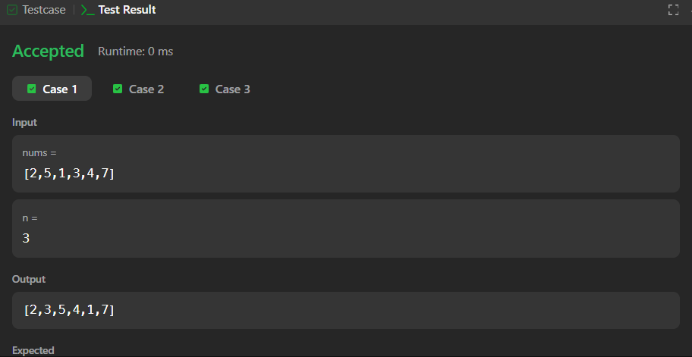
task 3:
class Solution {
public int removeElement(int[] nums, int val) {

int k = 0;

for (int i = 0; i < nums.length; i++) {
if (nums[i] != val) {
nums[k] = nums[i];
k++;
}
}

return k;
}
}
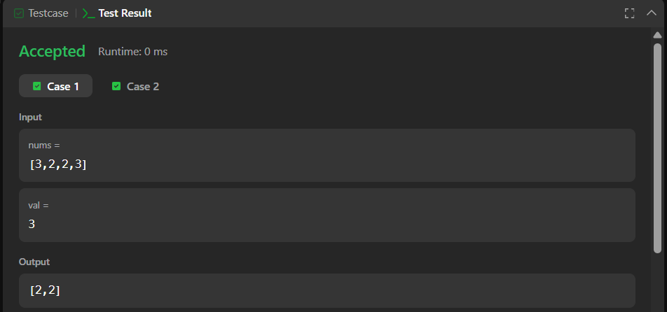
task 4:
class Solution {
public int removeDuplicates(int[] nums) {

int k = 1;

for (int i = 1; i < nums.length; i++) {

if (nums[i] != nums[i - 1]) {
nums[k] = nums[i];
k++;
}
}

return k;
}
}

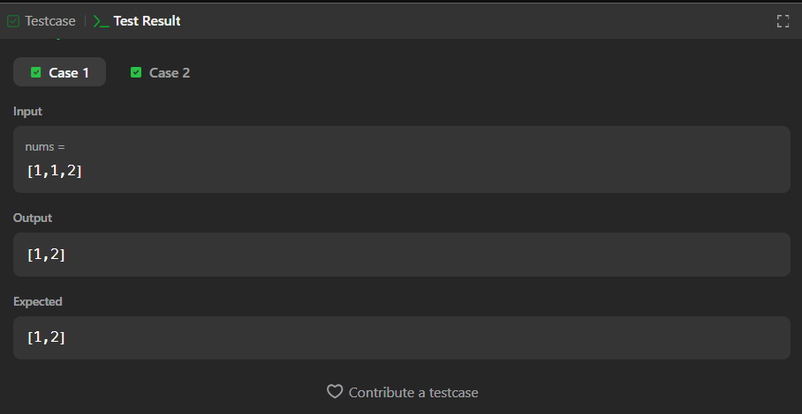

Task 5:
class Solution {
public int maxSubArray(int[] nums) {

int currentSum = nums[0];
int maxSum = nums[0];

for (int i = 1; i < nums.length; i++) {

currentSum = Math.max(nums[i], currentSum + nums[i]);

maxSum = Math.max(maxSum, currentSum);
}

return maxSum;
}
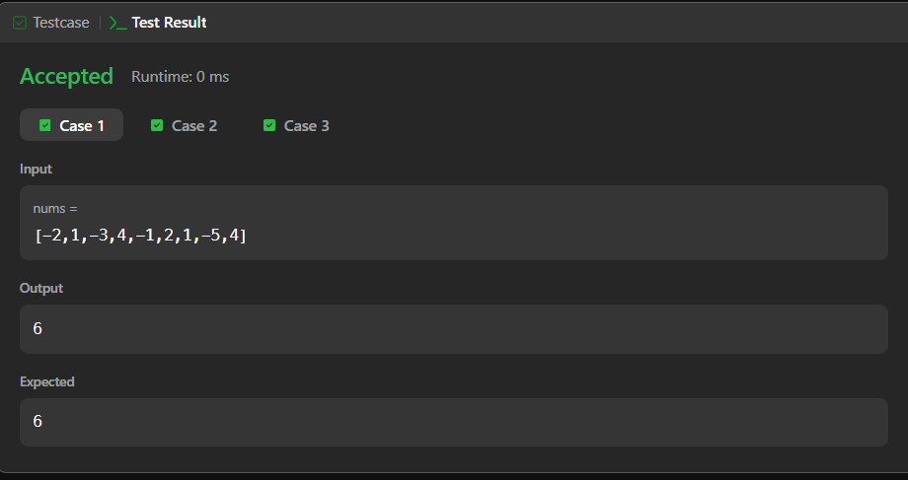
}

Task 6: class Solution {
public int largestAltitude(int[] gain) {

int altitude = 0;
int maxAltitude = 0;

for (int i = 0; i < gain.length; i++) {
altitude = altitude + gain[i];

if (altitude > maxAltitude) {
maxAltitude = altitude;
}
}

return maxAltitude;
}
}
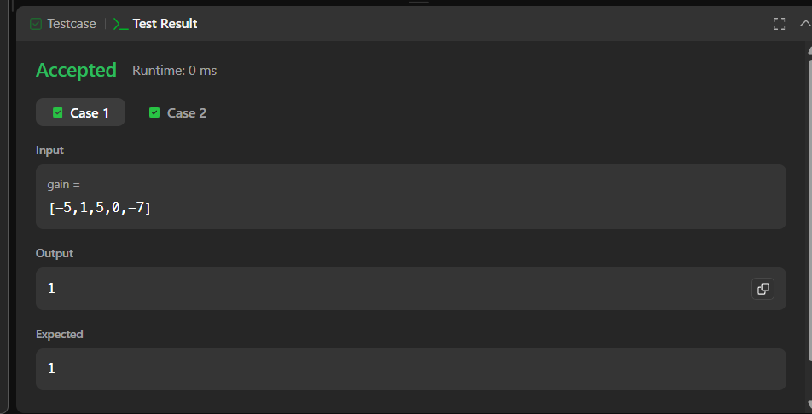
task 7:
class Solution {
public List<List<String>> groupAnagrams(String[] strs) {

HashMap<String, List<String>> map = new HashMap<>();

for (String s : strs) {
char[] chars = s.toCharArray();
Arrays.sort(chars);

String key = new String(chars);

if (!map.containsKey(key)) {
map.put(key, new ArrayList<>());
}

map.get(key).add(s);
}

return new ArrayList<>(map.values());
}
}
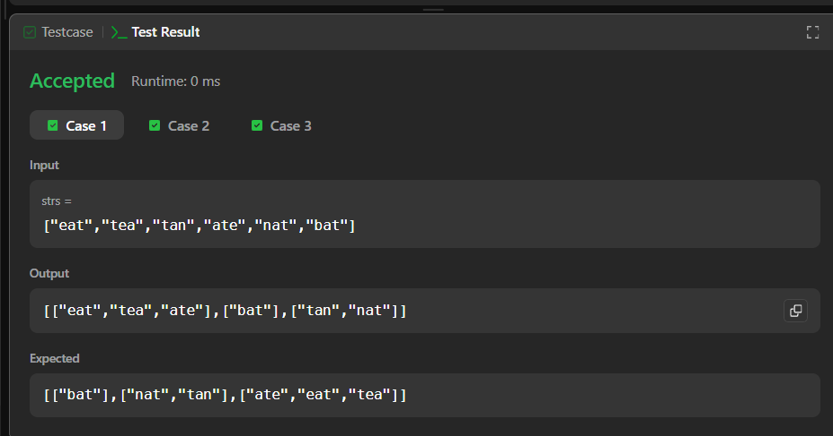
Task 8:
class Solution {
public int[] topKFrequent(int[] nums, int k) {

HashMap<Integer, Integer> map = new HashMap<>();

// Count frequency
for (int num : nums) {
map.put(num, map.getOrDefault(num, 0) + 1);
}

// Min Heap based on frequency
PriorityQueue<Integer> pq = new PriorityQueue<>(
(a, b) -> map.get(a) - map.get(b)
);

// Keep only k elements
for (int num : map.keySet()) {
pq.add(num);

if (pq.size() > k) {
pq.poll();
}
}

// Store answer
int[] ans = new int[k];

for (int i = 0; i < k; i++) {
ans[i] = pq.poll();
}

return ans;
}
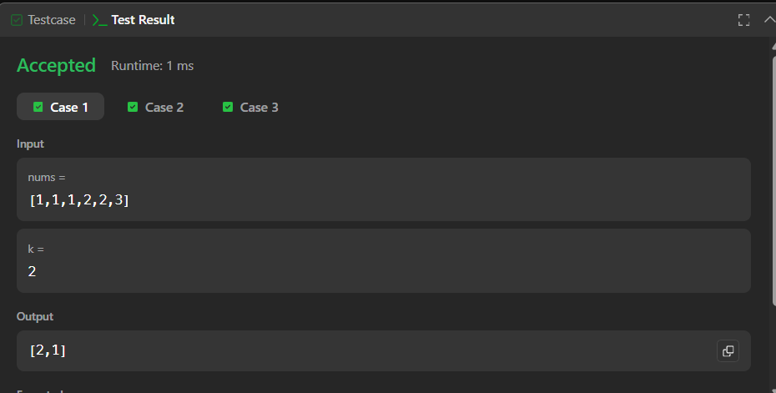
}
Task 9:
import java.util.*;

public class Main {
public static void main(String[] args) {

Scanner sc = new Scanner(System.in);

int n = sc.nextInt();
int m = sc.nextInt();

int[] arr = new int[n];

for (int i = 0; i < n; i++) {
arr[i] = sc.nextInt();
}

HashMap<Integer, Integer> map = new HashMap<>();

// First window
for (int i = 0; i < m; i++) {
map.put(arr[i], map.getOrDefault(arr[i], 0) + 1);
}

int max = map.size();

// Slide the window
for (int i = m; i < n; i++) {

// Add new element
map.put(arr[i], map.getOrDefault(arr[i], 0) + 1);

// Remove element leaving the window
int remove = arr[i - m];

map.put(remove, map.get(remove) - 1);

if (map.get(remove) == 0) {
map.remove(remove);
}

// Update maximum
max = Math.max(max, map.size());
}

System.out.println(max);
}
}
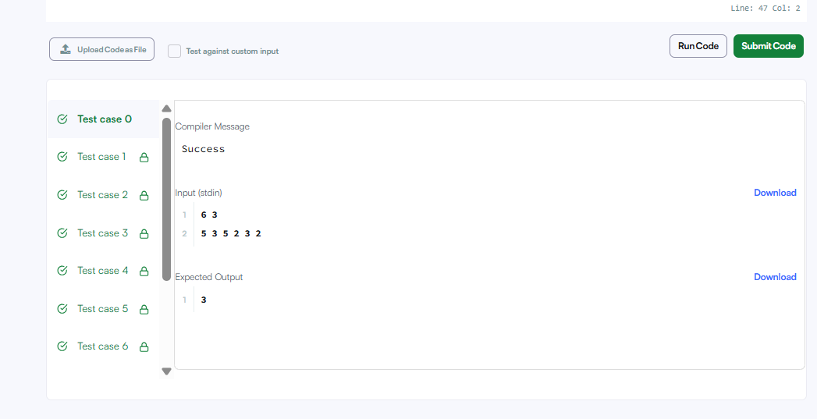
task 10:
import java.io.*;
import java.util.*;
import java.text.*;
import java.math.*;
import java.util.regex.*;

public class Solution {

public static void main(String[] args) {
Scanner s = new Scanner(System.in);
int t = s.nextInt();
String [] pair_left = new String[t];
String [] pair_right = new String[t];

for (int i = 0; i < t; i++) {
pair_left[i] = s.next();
pair_right[i] = s.next();
}

//Write your code here
HashSet<String> set = new HashSet<>();

for (int i = 0; i < t; i++) {

String pair = pair_left[i] + " " + pair_right[i];

set.add(pair);

System.out.println(set.size());
}
}
}
